Measurement properties of patient-reported outcome measures (PROMs) for women with Genitourinary Syndrome of Menopause: a systematic review
Michaela Gabes, Helge Knüttel PhD, Cecilia A. C. Prinsen PhD, Petra Stute MD, Christian J. Apfelbacher PhD
PROSPERO: CRD42018092384

Appendix 1: Search strategies

Searches in bibliographic databases according to the COSMIN recommendations
((population AND construct AND (measurement properties OR feasibility)) OR (individual measurement instruments AND measurement properties)) NOT (exclusion filter)
Searches as run on 2018-12-07.

EMBASE

Host Ovid, 1974–present, database code “oemezd”
Search strategy as exported from host.
Statement | Query | Hits | Remarks
1 | atrophic vaginitis/ or vagina atrophy/ or ((exp vagina/ or vagina disease/ or vagina pain/ or vaginal burning sensation/ or vaginal dryness/ or vaginal pruritus/ or vulva disease/ or vulva pruritus/ or vulvitis/ or vulvar vestibulitis/ or vulvovaginitis/) and (atrophy/ or exp "menopause and climacterium"/)) or (vaginitis or vaginosis or vulvitis or vulvovaginitis or vestibulitis).ti,ab,kw. or ((vulv* or vagin* or vulvovagin* or "vulvo vagin*" or genitourin* or "genito urin*" or urogenit* or "uro genit*" or genital) adj3 (atroph* or dystroph* or kraurosis or syndrome* or symptoms or dry* or odo?r or soreness or itching or prurit#s or irritat* or burning or stinging or soreness or pain* or hurting or discomfort or fissuring or ageing)).ti,ab,kw. or "genitourinary syndrome o# menopause".ti,ab,kw. or (dyspareunia/ or vulvodynia/ or vulvovaginal discomfort/ or vaginal discomfort/ or vulva kraurosis/) or (vulvar vestibulitis syndrome or vulvodynia* or vestibulodynia* or dyspareunia* or clitorodynia* or algopareuni* or vulvismus).ti,ab,kw. or ((pain* or unpleasant or discomfort) adj3 (coitus or coital or intercourse or penetrat* or cohabit* or sex or sexual or vulv* or vagin* or genital)).ti,ab,kw. or ((leukorrhea/ or vagina discharge/ or (vaginal discharge* or leukorrhea*).ti,ab,kw. or (vaginal vault prolapse/ or uterus prolapse/ or ((uter* or vagin*) adj3 prolapse).ti,ab,kw.) or (vagina bleeding/ or ((vagina* or post-coital or postcoital or coital or coitus or intercourse) adj3 (h?emorrhage* or bleeding)).ti,ab,kw.) or ("sexual dysfunction"/ or "female sexual dysfunction"/ or ((sex or sexual or psychosexual) adj2 (d#sfunction* or d#s function* or disorder* or symptoms or function* or health or wellness or well-being or satisfact* or dissatisfact* or pleasure or enjoyment or joy or problem* or complaint* or difficult* or symptom* or distress or stress or morbidity or actvit* or life or lifes or lives or aversion)).ti,ab,kw.) or (frigidity/ or (sexuality or intimacy or female genital self-image or frigid*).ti,ab,kw.) or (libido/ or "libido disorder"/ or "hypoactive sexual desire disorder"/ or sexual arousal disorder/ or (libido or arousal or ((sex or sexual) adj (desire* or drive* or interest* or disinterest*)) or (desire adj (d#sfunction* or d#s function* or disorder* or problem*))).ti,ab,kw.) or (lubrication/ or vaginal lubrication/ or (lubrication or arousal or (sexual adj (response or stimulation or excitement))).ti,ab,kw.) or (anorgasmia/ or orgasm disorder/ or (orgasm* or anorgas* or orgastic).ti,ab,kw.) or ("overactive bladder"/ or "neurogenic bladder"/ or ((overactive or neurogenic) adj (bladder or detrusor)).ti,ab,kw.) or (exp cystitis/ or (cystiti* or painful bladder syndrome).ti,ab,kw.) or (urinary tract infection/ or urinary tract infection*.ti,ab,kw.) or (urine incontinence/ or urge incontinence/ or (urin* adj3 (incontinen* or urgency)).ti,ab,kw.) or (dysuria/ or dysuria.ti,ab,kw.) or (nocturia/ or (nocturia or nycturia).ti,ab,kw.) or (micturition disorder/ or ((urination or micturition) adj disorder*).ti,ab,kw.)) and (exp "menopause and climacterium"/ or (menopaus* or perimenopaus* or peri-menopaus* or postmenopaus* or post-menopaus* or climacterium).ti,ab,kw.)) | 46811 | population
2 | "quality of life"/ or (HR-PRO or HRPRO or qol or QL or hrql or hrqol).ti,ab,kw. or (quality adj2 (life or living)).ti,ab,kw. or "daily life activity"/ or (activit* adj2 (daily adj (life or living))).ti,ab,kw. or "adl".ti,ab,kw. or "chronic limitation o# activity".ti,ab,kw. or "self care*".ti,ab,kw. or "health status"/ or (health adj2 (status or state or level* or index* or indices or profile*)).ti,ab,kw. or "patient-reported outcome"/ or (proms or proms or pro or pros).ti,ab,kw. or ((patient or self or carer or proxy) adj3 (appraisal* or appraised or report or reported or reporting or rated or rating or ratings or based or assessed or assessment or assessments)).ti,ab,kw. or ((disability or function or functional or functions or subjective or utility or utilities or wellbeing or well being) adj3 (outcome or outcomes or index or indices or instrument or instruments or measure or measures or questionnaire or questionnaires or profile or profiles or scale or scales or score or scores or status or survey or surveys)).ti,ab,kw. or (satisfaction or emotions or life-impact or sexual-impact or functioning or well-being).ti,ab,kw. | 1841367 | quality of life
3 | 1 and 2 | 11674 | population AND quality of life
4 | exp instrumentation/ or exp validation study/ or exp reproducibility/ or reproducib$.mp. or exp psychometry/ or psychometr$.mp. or clinimetr*.mp. or clinometr$.mp. or exp observer variation/ or observer variation.mp. or exp discriminant analysis/ or exp reliability/ or reliab$.mp. or exp Validity/ or valid$.mp. or coefficient.mp. or internal consistency.mp. or (cronbach$ and (alpha or alphas)).mp. or item correlation.mp. or item correlations.mp. or item selection.mp. or item selections.mp. or item reduction.mp. or item reductions.mp. or agreement.mp. or precision.mp. or imprecision.mp. or precise values.mp. or (test-retest or (test and retest) or (reliab$ and (test or retest)) or stability or interrater or inter-rater or intrarater or intra-rater or intertester or inter-tester or intratester or intra-tester or interobserver or inter-observer or intraobserver or intra-observer or intertechnician or intertechnician or intratechnician or intra-technician or interexaminer or inter-examiner or intraexaminer or intra-examiner or interassay or inter-assay or intraassay or intra-assay or interindividual or inter-individual or intraindividual or intra-individual or interparticipant or inter-participant or intraparticipant or intra-participant or kappa or kappa$ or coefficient of variation or repeatab$ or ((replicap$ or repeated) and (measure or measures or findings or result or results or test or tests))).mp. or (generaliza$ or generalisa$ or concordance or (intraclass and correlation$) or discriminative or known group or factor analysis or factor analyses or factor structure or factor structures or dimensionality or subscale$ or multitrait scaling analysis or multitrait scaling analyses or item discriminant or interscale correlation or interscale correlations or ((error or errors) and (measure$ or correlat$ or evaluat$ or accuracy or accurate or precision or mean)) or individual variability or interval variability or rate variability or variability analysis or (uncertainty and (measurement or measuring)) or standard error of measurement or sensitiv$ or responsive$ or (limit and detection) or minimal detectable concentration or interpretab$ or (small$ and (real or detectable) and (change or difference)) or meaningful change or minimal important change or minimal important difference or minimally important change or minimally important difference or minimal detectable change or minimal detectable difference or minimally detectable change or minimally detectable difference or minimal real change or minimal real difference or minimally real change or minimally real difference).mp. or (ceiling effect or floor effect or Item response model or IRT or Rasch or Differential item functioning or DIF or computer adaptive testing or item bank or cross-cultural equivalence).mp. | 7409808 | measurement properties
5 | (accepta* or "ease o# use" or practica* or feasib*).ti,ab. | 927776 | feasibility
6 | 4 or 5 | 7928691 | measurement properties OR feasibility
7 | 3 and 6 | 4906 | population AND quality of life AND (measurement properties OR feasibility)
8 | ("vulvovaginal symptoms questionnaire" or (VSQ and (vulv* or vagin*)) or "Day-to-Day Impact o# Vaginal Aging Questionnaire" or "diva questionnaire" or "Vaginal symptom bothersomeness scale" or "Female sexual problems measure" or "Female Sexual Function Index" or FSFI or "Female Genital Self Image Scale" or FGSIS or "Sexual Adjustment and Body Image Scale" or SABIS or "German Questionnaire on Feelings o# Inadequacy in Social and Sexual Situations" or "FUSS social scale" or "FUSS sexual scale" or "Geriatric Sexuality Inventory").mp. | 3812 | individual measurement instruments
9 | 4 and 8 | 1631 | individual measurement instruments AND measurement properties
10 | 7 or 9 | 5876 | (population AND quality of life AND (measurement properties OR feasibility)) OR (individual measurement instruments AND measurement properties)
11 | (conference abstract or conference paper or conference review or editorial or erratum or letter or note).pt. | 6540863 | exclusion filter
12 | 10 not 11 | 3166 | ((population AND quality of life AND (measurement properties OR feasibility)) OR (individual measurement instruments AND measurement properties)) NOT (exclusion filter)
13 | (english or french or german or italian).lg. | 28535627 | language
14 | 12 and 13 | 3052 | (((population AND quality of life AND (measurement properties OR feasibility)) OR (individual measurement instruments AND measurement properties)) NOT (exclusion filter)) AND language
15 | ("1052045056" or [...deleted...] or "8075507").an. | 2827 | Records found on 2018-04-23
16 | 14 not 15 | 226 | Only records found newly in this update search.

MEDLINE

Host Ovid, 1946–present, database code “ppezv”
Search strategy as exported from host.

Statement | Query | Hits | Remarks
1 | atrophic vaginitis/ or ((exp vagina/ or vaginal diseases/ or vaginitis/ or exp vulva/ or vulvar diseases/ or pruritus vulvae/ or vulvitis/ or vulvar vestibulitis/ or vulvovaginitis/) and (atrophy/ or menopause/ or perimenopause/ or postmenopause/)) or (vaginitis or vaginosis or vulvitis or vulvovaginitis or vestibulitis).ti,ab,kf. or ((vulv* or vagin* or vulvovagin* or "vulvo vagin*" or genitourin* or "genito urin*" or urogenit* or "uro genit*" or genital) adj3 (atroph* or dystroph* or kraurosis or syndrome* or symptoms or dry* or odo?r or soreness or itching or prurit#s or irritat* or burning or stinging or soreness or pain* or hurting or discomfort or fissuring or ageing)).ti,ab,kf. or "genitourinary syndrome o# menopause".ti,ab,kf. or (dyspareunia/ or vulvodynia/) or (vulvar vestibulitis syndrome or vulvodynia* or vestibulodynia* or dyspareunia* or clitorodynia* or algopareuni* or vulvismus).ti,ab,kf. or ((pain* or unpleasant or discomfort) adj3 (coitus or coital or intercourse or penetrat* or cohabit* or sex or sexual or vulv* or vagin* or genital)).ti,ab,kf. or ((exp Vaginal Discharge/ or (vaginal discharge* or Leukorrhea*).ti,ab,kf. or (Uterine Prolapse/ or ((uter* or vagin*) adj3 prolapse).ti,ab,kf.) or ((Vagina* or post-coital or postcoital or coital or coitus or intercourse) adj3 (H?emorrhage* or Bleeding)).ti,ab,kf. or ("Sexual Dysfunction, Physiological"/ or "Sexual Dysfunctions, Psychological"/ or ((sex or sexual or psychosexual) adj2 (d#sfunction* or d#s function* or disorder* or symptoms or function* or health or wellness or well-being or satisfact* or dissatisfact* or pleasure or enjoyment or joy or problem* or complaint* or difficult* or symptom* or distress or stress or morbidity or actvit* or life or lifes or lives or aversion)).ti,ab,kf.) or (sexuality or intimacy or female genital self-image or frigid*).ti,ab,kf. or (Libido/ or (Libido or arousal or ((sex or sexual) adj (desire* or drive* or interest* or disinterest*)) or (desire adj (d#sfunction* or d#s function* or disorder* or problem*))).ti,ab,kf.) or (lubrication or arousal or (sexual adj (response or stimulation or excitement))).ti,ab,kf. or (orgasm* or anorgas* or orgastic).ti,ab,kf. or ("Urinary Bladder, Overactive"/ or "Urinary Bladder, Neurogenic"/ or (Overactive adj (Bladder or detrusor)).ti,ab,kf.) or (Cystitis/ or (Cystiti* or Painful Bladder Syndrome).ti,ab,kf.) or (Urinary Tract Infections/ or Urinary Tract Infection*.ti,ab,kf.) or (Urinary Incontinence/ or (Urin* adj3 (Incontinen* or urgency)).ti,ab,kf.) or (Dysuria/ or Dysuria.ti,ab,kf.) or (Nocturia/ or (Nocturia or Nycturia).ti,ab,kf.) or (Urination Disorders/ or ((urination or micturition) adj disorder*).ti,ab,kf.)) and (Menopause/ or Perimenopause/ or Postmenopause/ or (menopaus* or perimenopaus* or peri-menopaus* or postmenopaus* or post-menopaus* or climacterium).ti,ab,kf.)) | 27777 | population
2 | "Quality of Life"/ or (HR-PRO or HRPRO or qol or QL or hrql or hrqol).ti,ab,kf. or (quality adj2 (life or living)).ti,ab,kf. or exp "Activities of Daily Living"/ or (activit* adj2 (daily adj (life or living))).ti,ab,kf. or "adl".ti,ab,kf. or "chronic limitation o# activity".ti,ab,kf. or "self care*".ti,ab,kf. or "Health Status"/ or (health adj2 (status or state or level* or index* or indices or profile*)).ti,ab,kf. or "Patient Reported Outcome Measures"/ or (proms or proms or pro or pros).ti,ab,kf. or ((patient or self or carer or proxy) adj3 (appraisal* or appraised or report or reported or reporting or rated or rating or ratings or based or assessed or assessment or assessments)).ti,ab,kf. or ((disability or function or functional or functions or subjective or utility or utilities or wellbeing or well being) adj3 (outcome or outcomes or index or indices or instrument or instruments or measure or measures or questionnaire or questionnaires or profile or profiles or scale or scales or score or scores or status or survey or surveys)).ti,ab,kf. or (satisfaction or emotions or life-impact or sexual-impact or functioning or well-being).ti,ab,kf. | 1272219 | quality of life
3 | 1 and 2 | 5283 | population AND quality of life
4 | (instrumentation or methods).sh. or (Validaton Studies or Comparative Study).pt. or exp Psychometrics/ or psychometr*.ti,ab. or (clinimetr* or clinometr*).tw. or exp "Outcome Assessment (Health Care)"/ or outcome assessment.ti,ab. or outcome measure*.tw. or exp Observer Variation/ or observer variation.ti,ab. or exp Health Status Indicators/ or exp "Reproducibility of Results"/ or reproducib*.ti,ab. or exp Discriminant Analysis/ or (reliab* or unreliab* or valid* or coefficient or homogeneity or homogeneous or "internal consistency").ti,ab. or (cronbach* and (alpha or alphas)).ti,ab. or (item and (correlation* or selection* or reduction*)).ti,ab. or (agreement or precision or imprecision or "precise values" or test-retest).ti,ab. or (test and retest).ti,ab. or (reliab* and (test or retest)).ti,ab. or (stability or interrater or inter-rater or intrarater or intra-rater or intertester or inter-tester or intratester or intra-tester or interobserver or inter-observer or intraobserver or intra-observer or intertechnician or inter-technician or intratechnician or intra-technician or interexaminer or inter-examiner or intraexaminer or intra-examiner or interassay or inter-assay or intraassay or intra-assay or interindividual or inter-individual or intraindividual or intra-individual or interparticipant or inter-participant or intraparticipant or intra-participant or kappa or kappa's or kappas or repeatab*).ti,ab. or ((replicab* or repeated) and (measure or measures or findings or result or results or test or tests)).ti,ab. or (generaliza* or generalisa* or concordance).ti,ab. or (intraclass and correlation*).ti,ab. or (discriminative or "known group" or factor analysis or factor analyses or dimension* or subscale*).ti,ab. or (multitrait and scaling and (analysis or analyses)).ti,ab. or (item discriminant or interscale correlation* or error or errors or "individual variability").ti,ab. or (variability and (analysis or values)).ti,ab. or (uncertainty and (measurement or measuring)).ti,ab. or ("standard error o# measurement" or sensitiv* or responsive*).ti,ab. or ((minimal or minimally or clinical or clinically) and (important or significant or detectable) and (change or difference)).ti,ab. or (small* and (real or detectable) and (change or difference)).ti,ab. or (meaningful change or "ceiling effect" or "floor effect" or "Item response model" or IRT or Rasch or "Differential item functioning" or DIF or "computer adaptive testing" or "item bank" or "cross-cultural equivalence").ti,ab. | 6823593 | measurement properties
5 | (accepta* or "ease o# use" or practica* or feasib*).ti,ab. | 708356 | feasibility
6 | 4 or 5 | 7217039 | measurement properties OR feasibility
7 | 3 and 6 | 2772 | population AND quality of life AND (measurement properties OR feasibility)
8 | ("vulvovaginal symptoms questionnaire" or (VSQ and (vulv* or vagin*)) or "Day-to-Day Impact o# Vaginal Aging Questionnaire" or "diva questionnaire" or "Vaginal symptom bothersomeness scale" or "Female sexual problems measure" or "Female Sexual Function Index" or FSFI or "Female Genital Self Image Scale" or FGSIS or "Sexual Adjustment and Body Image Scale" or SABIS or "German Questionnaire on Feelings o# Inadequacy in Social and Sexual Situations" or "FUSS social scale" or "FUSS sexual scale" or "Geriatric Sexuality Inventory").mp. | 1625 | individual measurement instruments
9 | 4 and 8 | 1027 | individual measurement instruments AND measurement properties
10 | 7 or 9 | 3480 | (population AND quality of life AND (measurement properties OR feasibility)) OR (individual measurement instruments AND measurement properties)
11 | ("addresses" or "biography" or "case reports" or "comment" or "directory" or "editorial" or "festschrift" or "interview" or "lectures" or "legal cases" or "legislation" or "letter" or "news" or "newspaper article" or "patient education handout" or "popular works" or "congresses" or "consensus development conference" or "consensus development conference, nih" or "practice guideline").pt. or (exp "animals"/ not "humans"/) | 8304771 | exclusion filter
12 | 10 not 11 | 3405 | ((population AND quality of life AND (measurement properties OR feasibility)) OR (individual measurement instruments AND measurement properties)) NOT (exclusion filter)
13 | (english or french or german or italian).lg. | 26331812 | language
14 | 12 and 13 | 3323 | (((population AND quality of life AND (measurement properties OR feasibility)) OR (individual measurement instruments AND measurement properties)) NOT (exclusion filter)) AND language
15 | ("10037541" or [...deleted...] or "9928575").ui. | 3114 | Records found on 2018-04-23
16 | 14 not 15 | 211

Web of Science

Science Citation Index Expanded (1965–present) and Social Sciences Citation Index (1990–present)
Web of Science does not provide means to export search strategies in a human readable/text format. Therefore, we include screenshots in order to document the result with the host. For the prepared search statements in text format see below.

Screenshots from Web of Science
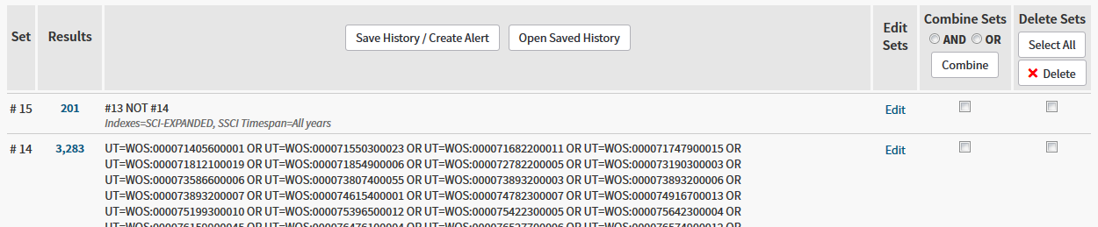
[List of records found earlier shortened]
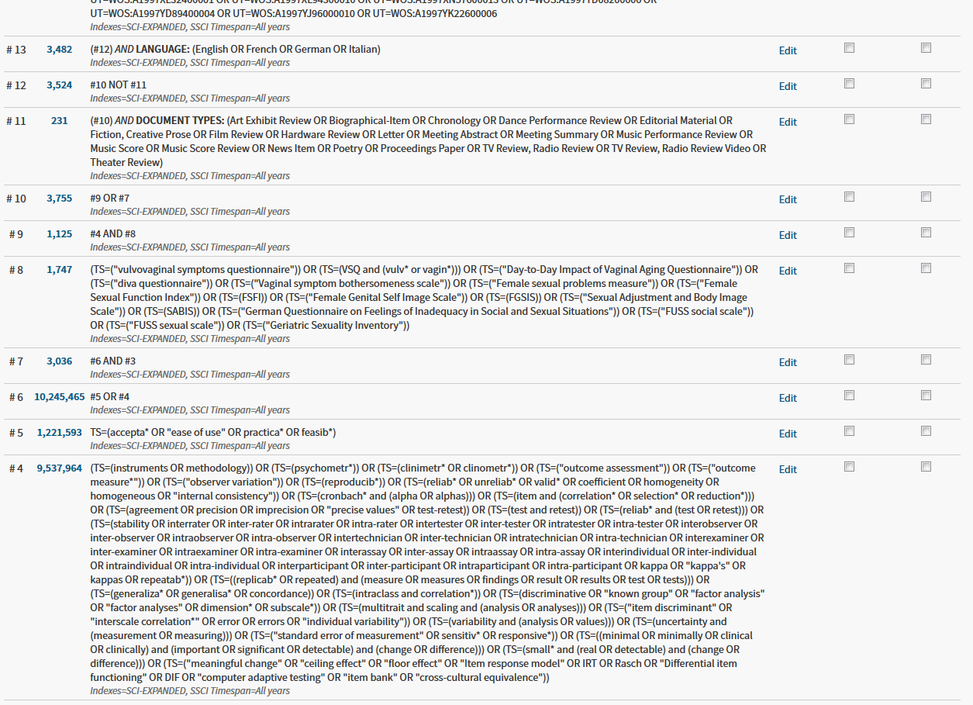
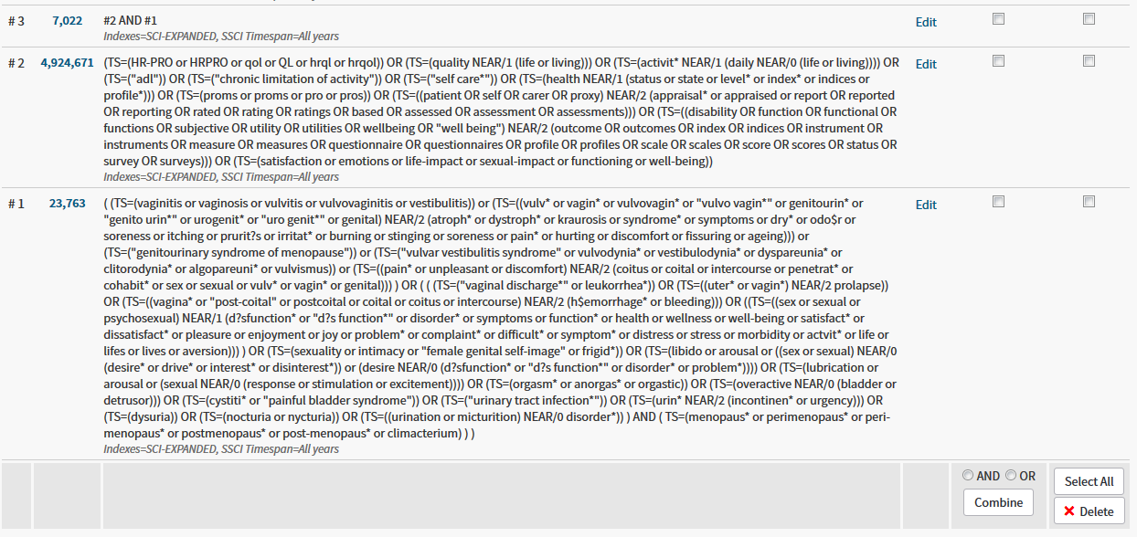

Prepared search statements that were entered into Web of Science

### Population: Genitourinary syndrome of menopause

(
(TS=(vaginitis or vaginosis or vulvitis or vulvovaginitis or vestibulitis)) or
(TS=((vulv* or vagin* or vulvovagin* or "vulvo vagin*" or genitourin* or "genito urin*" or urogenit* or "uro genit*" or genital) NEAR/2 (atroph* or dystroph* or kraurosis or syndrome* or symptoms or dry* or odo$r or soreness or itching or prurit?s or irritat* or burning or stinging or soreness or pain* or hurting or discomfort or fissuring or ageing))) or
(TS=("genitourinary syndrome of menopause")) or
(TS=("vulvar vestibulitis syndrome" or vulvodynia* or vestibulodynia* or dyspareunia* or clitorodynia* or algopareuni* or vulvismus)) or
(TS=((pain* or unpleasant or discomfort) NEAR/2 (coitus or coital or intercourse or penetrat* or cohabit* or sex or sexual or vulv* or vagin* or genital)))
) OR (
(
(TS=("vaginal discharge*" or leukorrhea*)) OR
(TS=((uter* or vagin*) NEAR/2 prolapse)) OR
(TS=((vagina* or "post-coital" or postcoital or coital or coitus or intercourse) NEAR/2 (h$emorrhage* or bleeding))) OR
((TS=((sex or sexual or psychosexual) NEAR/1 (d?sfunction* or "d?s function*" or disorder* or symptoms or function* or health or wellness or well-being or satisfact* or dissatisfact* or pleasure or enjoyment or joy or problem* or complaint* or difficult* or symptom* or distress or stress or morbidity or actvit* or life or lifes or lives or aversion))) ) OR
(TS=(sexuality or intimacy or "female genital self-image" or frigid*)) OR
(TS=(libido or arousal or ((sex or sexual) NEAR/0 (desire* or drive* or interest* or disinterest*)) or (desire NEAR/0 (d?sfunction* or "d?s function*" or disorder* or problem*)))) OR
(TS=(lubrication or arousal or (sexual NEAR/0 (response or stimulation or excitement)))) OR
(TS=(orgasm* or anorgas* or orgastic)) OR
(TS=(overactive NEAR/0 (bladder or detrusor))) OR
(TS=(cystiti* or "painful bladder syndrome")) OR
(TS=("urinary tract infection*")) OR
(TS=(urin* NEAR/2 (incontinen* or urgency))) OR
(TS=(dysuria)) OR
(TS=(nocturia or nycturia)) OR
(TS=((urination or micturition) NEAR/0 disorder*))
) AND (
TS=(menopaus* or perimenopaus* or peri-menopaus* or postmenopaus* or post-menopaus* or climacterium)
)
)

### Construct: Quality of Life

(TS=(HR-PRO or HRPRO or qol or QL or hrql or hrqol)) OR
(TS=(quality NEAR/1 (life or living))) OR
(TS=(activit* NEAR/1 (daily NEAR/0 (life or living)))) OR
(TS=("adl")) OR
(TS=("chronic limitation of activity")) OR
(TS=("self care*")) OR
(TS=(health NEAR/1 (status or state or level* or index* or indices or profile*))) OR
(TS=(proms or proms or pro or pros)) OR
(TS=((patient OR self OR carer OR proxy) NEAR/2 (appraisal* or appraised or report OR reported OR reporting OR rated OR rating OR ratings OR based OR assessed OR assessment OR assessments))) OR
(TS=((disability OR function OR functional OR functions OR subjective OR utility OR utilities OR wellbeing OR "well being") NEAR/2 (outcome OR outcomes OR index OR indices OR instrument OR instruments OR measure OR measures OR questionnaire OR questionnaires OR profile OR profiles OR scale OR scales OR score OR scores OR status OR survey OR surveys))) OR
(TS=(satisfaction or emotions or life-impact or sexual-impact or functioning or well-being))

### Measurement properties

(TS=(instruments OR methodology)) OR
(TS=(psychometr*)) OR
(TS=(clinimetr* OR clinometr*)) OR
(TS=("outcome assessment")) OR
(TS=("outcome measure*")) OR
(TS=("observer variation")) OR
(TS=(reproducib*)) OR
(TS=(reliab* OR unreliab* OR valid* OR coefficient OR homogeneity OR homogeneous OR "internal consistency")) OR
(TS=(cronbach* and (alpha OR alphas))) OR
(TS=(item and (correlation* OR selection* OR reduction*))) OR
(TS=(agreement OR precision OR imprecision OR "precise values" OR test-retest)) OR
(TS=(test and retest)) OR
(TS=(reliab* and (test OR retest))) OR
(TS=(stability OR interrater OR inter-rater OR intrarater OR intra-rater OR intertester OR inter-tester OR intratester OR intra-tester OR interobserver OR inter-observer OR intraobserver OR intra-observer OR intertechnician OR inter-technician OR intratechnician OR intra-technician OR interexaminer OR inter-examiner OR intraexaminer OR intra-examiner OR interassay OR inter-assay OR intraassay OR intra-assay OR interindividual OR inter-individual OR intraindividual OR intra-individual OR interparticipant OR inter-participant OR intraparticipant OR intra-participant OR kappa OR "kappa's" OR kappas OR repeatab*)) OR
(TS=((replicab* OR repeated) and (measure OR measures OR findings OR result OR results OR test OR tests))) OR
(TS=(generaliza* OR generalisa* OR concordance)) OR
(TS=(intraclass and correlation*)) OR
(TS=(discriminative OR "known group" OR "factor analysis" OR "factor analyses" OR dimension* OR subscale*)) OR
(TS=(multitrait and scaling and (analysis OR analyses))) OR
(TS=("item discriminant" OR "interscale correlation*" OR error OR errors OR "individual variability")) OR
(TS=(variability and (analysis OR values))) OR
(TS=(uncertainty and (measurement OR measuring))) OR
(TS=("standard error of measurement" OR sensitiv* OR responsive*)) OR
(TS=((minimal OR minimally OR clinical OR clinically) and (important OR significant OR detectable) and (change OR difference))) OR
(TS=(small* and (real OR detectable) and (change OR difference))) OR
(TS=("meaningful change" OR "ceiling effect" OR "floor effect" OR "Item response model" OR IRT OR Rasch OR "Differential item functioning" OR DIF OR "computer adaptive testing" OR "item bank" OR "cross-cultural equivalence"))

### Feasibility

TS=(accepta* OR "ease of use" OR practica* OR feasib*)

### Additional search for individual measurement instruments

(TS=("vulvovaginal symptoms questionnaire")) OR
(TS=(VSQ and (vulv* or vagin*))) OR
(TS=("Day-to-Day Impact of Vaginal Aging Questionnaire")) OR
(TS=("diva questionnaire")) OR
(TS=("Vaginal symptom bothersomeness scale")) OR
(TS=("Female sexual problems measure")) OR
(TS=("Female Sexual Function Index")) OR
(TS=(FSFI)) OR
(TS=("Female Genital Self Image Scale")) OR
(TS=(FGSIS)) OR
(TS=("Sexual Adjustment and Body Image Scale")) OR
(TS=(SABIS)) OR
(TS=("German Questionnaire on Feelings of Inadequacy in Social and Sexual Situations")) OR
(TS=("FUSS social scale")) OR
(TS=("FUSS sexual scale")) OR
(TS=("Geriatric Sexuality Inventory"))

### Exclusion filter
Filter for unwanted document types, then NOT them out:

DOCUMENT TYPES: (Art Exhibit Review OR Biographical-Item OR Chronology OR Dance Performance Review OR Editorial Material OR Fiction, Creative Prose OR Film Review OR Hardware Review OR Letter OR Meeting Abstract OR Meeting Summary OR Music Performance Review OR Music Score OR Music Score Review OR News Item OR Poetry OR Proceedings Paper OR TV Review, Radio Review OR TV Review, Radio Review Video OR Theater Review)

# Filter for publication language

Filter: LANGUAGE: (English OR French OR German OR Italian)

