Supplemental data, Results:
Ceftazidime (CFT) and cefepime (CFP) antagonize 5-fluoroucacil (5-FU)'s effect on Caco-2 cells
According to Bracht et al (REF), Caco-2 cells are sensitive to 5-fluorouracil (5-FU); therefore, lower concentrations of 5-FU were selected for this experiment. Caco-2 cells were exposed to 5-FU (4 µM), ceftazidime (CFT, 100 µg/mL), cefepime (CFP, 50 µg/mL), and their combinations for 24 h, the cell viability was investigated using an MTT-assay. The cell viability of Caco-2 cells was reduced significantly (40%) in response to 5-FU, while in combination with either of the antibiotics, a strong antagonism (p ≤ 0.001) was observed. Similar to DLD-1 cells, CFT reduced the viability of Caco-2 cells by 25%.
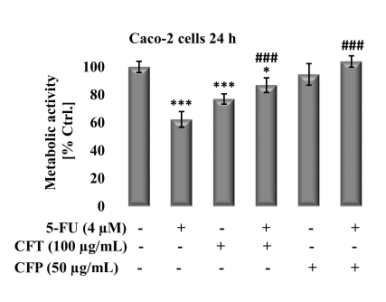
Figure 1. Ceftazidime (CFT) and cefepime (CFP) antagonize 5-fluoroucacil (5-FU)'s effect on Caco-2 cells. Effect of 5-FU (4 µM), CFP (50 µg/mL), CFT (100 µg/mL) and their combinations (5-FU/CFT and 5-FU/CFP) 24 h post-treatment on the metabolic activity of Caco-2 cells was measured using MTT assay. Results are expressed with respect to their respective control. Each value is the mean ± SEM of three independent experiments. Statistical analysis was performed using one tailed student t-test. ***P<0.001 significant to control untreated cells; ###P<0.001 significant with respect to 5-FU.
(REF) Bracht K et al, Br J Cancer 103, 340–346 (2010). https://doi.org/10.1038/sj.bjc.6605780

